Project Management Professional (PMP)
شهادة أخصائي إدارة المشاريع

By
Integrated Development Academy
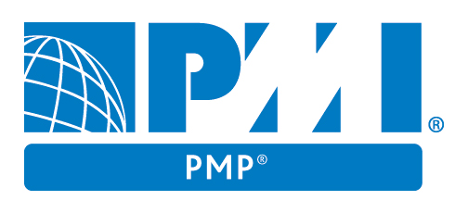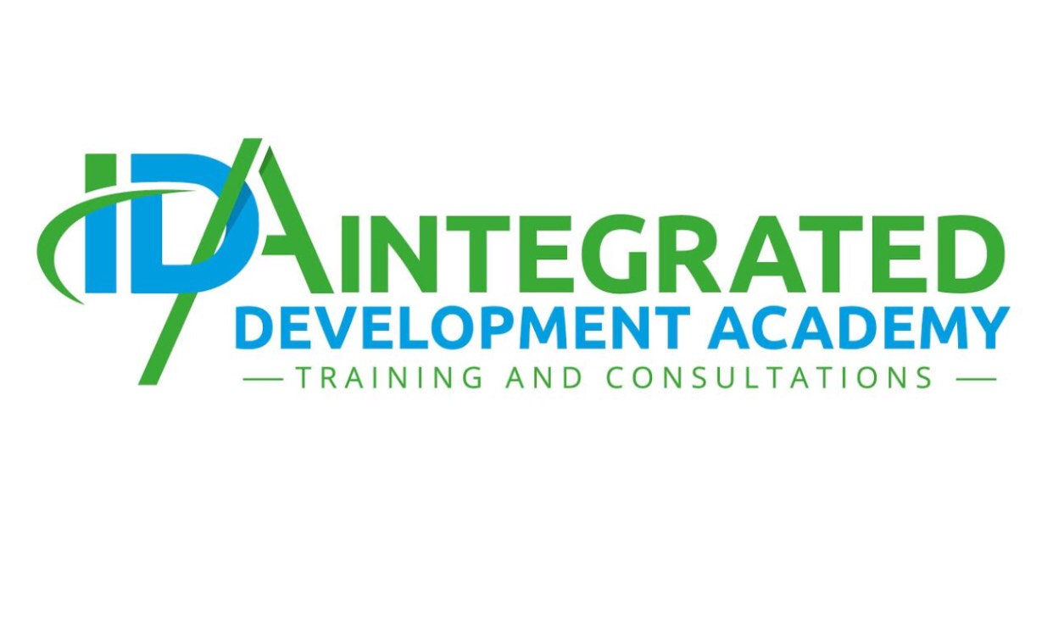



لتأهيل لشهادة محاسب إداري معتمد

Become a project hero
- Introduction

The Project Management Professional (PMP) is the most important industry-recognized certification for project managers.

The PMP is the gold standard of project management certification. Recognized and demanded by organizations worldwide, the PMP validates your competence to perform in the role of a project manager, leading and directing projects and teams.

You can find PMPs leading projects in nearly every country and, unlike other certifications that focus on a particular geography or domain, the PMP is truly global. As a PMP, you can work in virtually any industry, with any methodology and in any location.

- Benefits of Becoming a PMP

The PMP can also provide a significant advantage when it comes to salary and earning potential. Among survey respondents to PMI’s Earning Power Salary Survey, those with a PMP certification garner a higher salary (20% higher on average) than those without a PMP certification.*

Employers benefit as well. When more than one-third of their project managers are PMP-certified, organizations complete more of their projects on time, on budget and meeting original goals.

The PMP signifies that you speak and understand the global language of project management and connects you to a community of professionals, organizations and experts worldwide. Become a PMP and become a project hero.

- Who Should Apply

If you’re an experienced project manager responsible for all aspects of project delivery, leading and directing cross-functional teams, then the PMP is the right choice for you.

- Prerequisites

- Secondary degree (high school diploma, associate’s degree or the global equivalent)
- 7,500 hours leading and directing projects
- 35 hours of project management education
OR
- Four-year degree
- 4,500 hours leading and directing projects
- 35 hours of project management education

- Gain and Maintain you PMP

- The certification exam has 200 multiple-choice questions, and you have four hours to complete it.
- To maintain your PMP, you must earn 60 professional development units (PDUs) every three years. To stay certified, you’ll need to participate in professional development activities, and earn and report professional development units (PDUs.) There are lots of ways to earn PDUs and nearly unlimited opportunities.

- Certification Process

1. Fulfill Eligibility Criteria

All PMI certifications require you to meet domain experience levels, educational levels or both before you apply. You will need to provide us with the details of this experience and/or education, so it’s best to gather and prepare this information before you open the application.
To find out the eligibility requirements, consult the handbook for the certification that interests you. Each one has unique eligibility criteria.

2. Complete Application

Once you’ve determined you meet the eligibility criteria, it’s time to apply. Collect the following information and then use our online certification system to guide you through the process.
- Contact information — email, address, phone number
- Education attained — school attended, level of education attained, degree date
- Domain experience — details of the projects, programs, portfolios you’ve worked on including qualifying hours, dates of employment, role, organization details, reference, and experience summary
- Domain education — names of courses completed, institutions attended, dates, qualifying hours
Once you open an application, it will remain active for 90 days after which time it will close.
Tip: To complete the application quickly, gather all of the information and documentation you need before opening it. Otherwise, it will likely take you multiple sessions to complete.

3. Application Review

Once we receive your application, we’ll verify that you meet the eligibility criteria and that your experience and/or education is valid and consistent with the guidelines stated in the certification handbook.
Typically the application review period will take 5–10 days, depending on the certification. Once it’s complete, we’ll email you to move on to the next step.
If we have any questions or issues with your application, we’ll email you further instructions and direction.
For each certification, a specified percentage of applications are randomly selected for audit. PMI conducts application audits to confirm the experience and/or education documented on certification applications. The purpose of the audit is to enhance the credibility of the certification program and of the certification holders.

4. Payment

After we notify you that your application is approved, it’s time to provide payment so you can move to the final stage. The fastest and easiest way to pay is through our online certification system.
Once payment is received, we’ll email you an eligibility number that you’ll use to schedule your test appointment. You are eligible for one year, and you may take the exam up to three times during that year.

5. Schedule Test Appointment

Your test will occur at one of Prometric’s worldwide testing sites. Schedule your appointment online at Prometric.com/PMI using your eligibility number.
Then all that’s left is to test.

- Registration Price

Member: US$405.00
Non-member: US$555.00

- Training Plan
Program Duration:
36 Hours / 4 hours per day (4.30-8.30 PM)

Training Course Fees:
- For Individuals: JD 400
- For Groups: Upon Agreement

Trainer / Facilitator:
- Fast facts about exams

- For More inquiries, contact:
Telephone: +962 6 5151991 Mobile: +962 77 0818140
Email: info@ida.edu.jo Website: www.ida.edu.jo
Address: Abu Al-Hajj Commercial Complex – Queen Rania St – 5th Floor – Office 511 – Amman Jordan
 Integrated Development Academy

